AI Recommendation Logic
Project Overview
This project is a simple AI Recommendation System developed using Python. The system recommends books based on user interests using similarity matching logic.
The user enters one or more interests, and the system compares those interests with predefined book tags. A match score is calculated for each book, and books with the highest scores are recommended to the user.
Objective
To build a recommendation system that matches user preferences with item attributes and provides relevant recommendations.
Features
- Accepts user interests as input
- Uses similarity-based matching logic
- Calculates match scores
- Displays personalized book recommendations
- Supports multiple interests
- Handles cases where no matching recommendations are found
Technologies Used
- Python
- Dictionaries
- Loops
- Conditional Statements
- Sorting
Dataset
The system contains a collection of books and their associated tags:
- Atomic Habits
- Rich Dad Poor Dad
- The Alchemist
- Deep Work
- Think and Grow Rich
Tags include motivation, finance, productivity, business, success, career, self-help, and more.
How It Works
- The user enters interests separated by commas.
- The program converts the input into a list.
- Each interest is compared with the tags of every book.
- A match score is calculated based on the number of matching tags.
- Books are sorted according to their match scores.
- The highest-ranking recommendations are displayed.
Sample Input
finance, motivation
Sample Output
Recommended Books:
Think and Grow Rich - Match Score: 2
Atomic Habits - Match Score: 1
Rich Dad Poor Dad - Match Score: 1
The Alchemist - Match Score: 1
AI Concepts Used
- Recommendation Systems
- Similarity Matching
- Pattern Matching
- User Preference Analysis
Screenshots
Code Screenshot
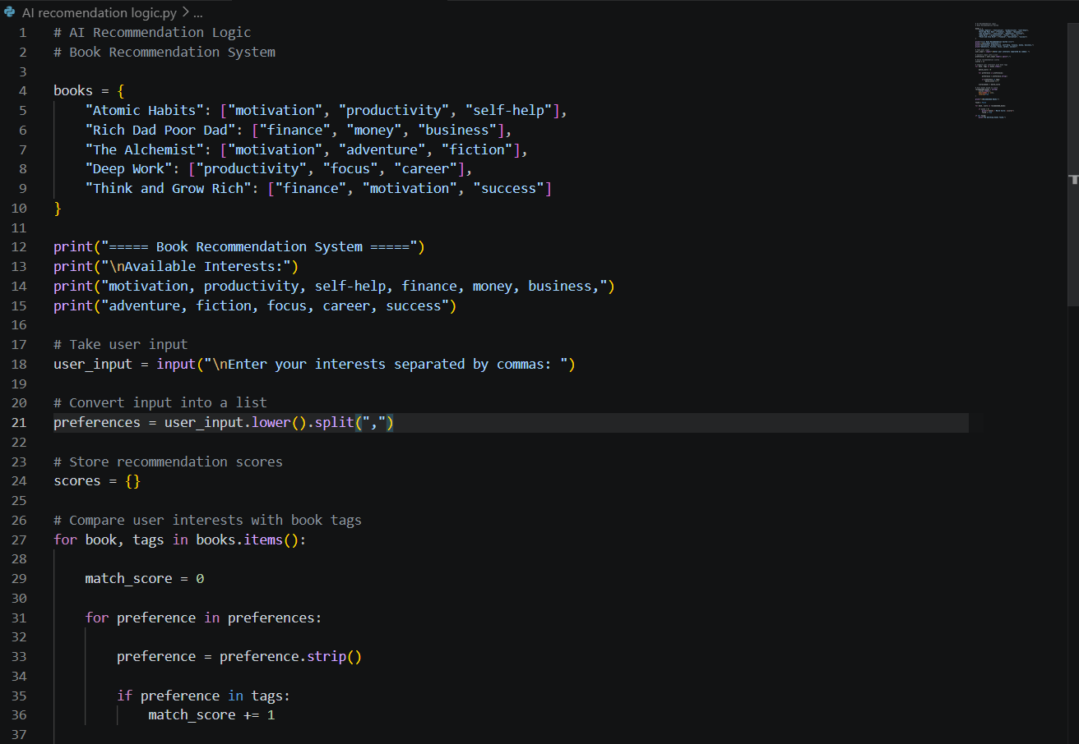

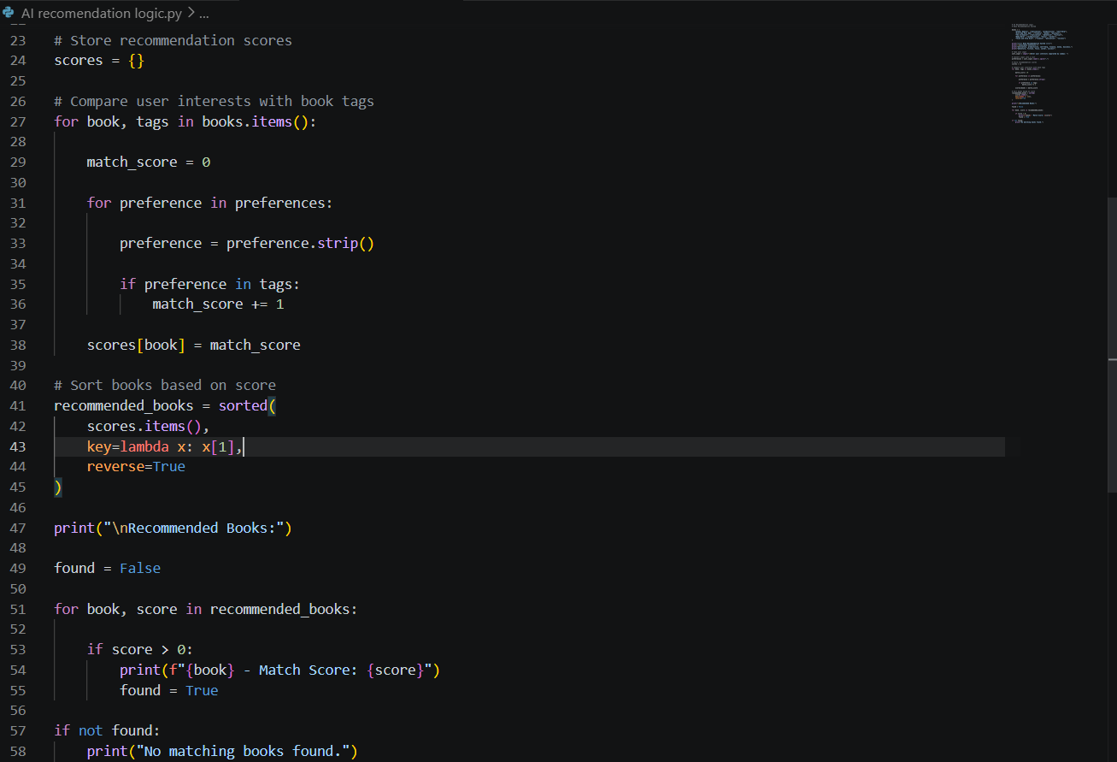

Recommendation Output 1

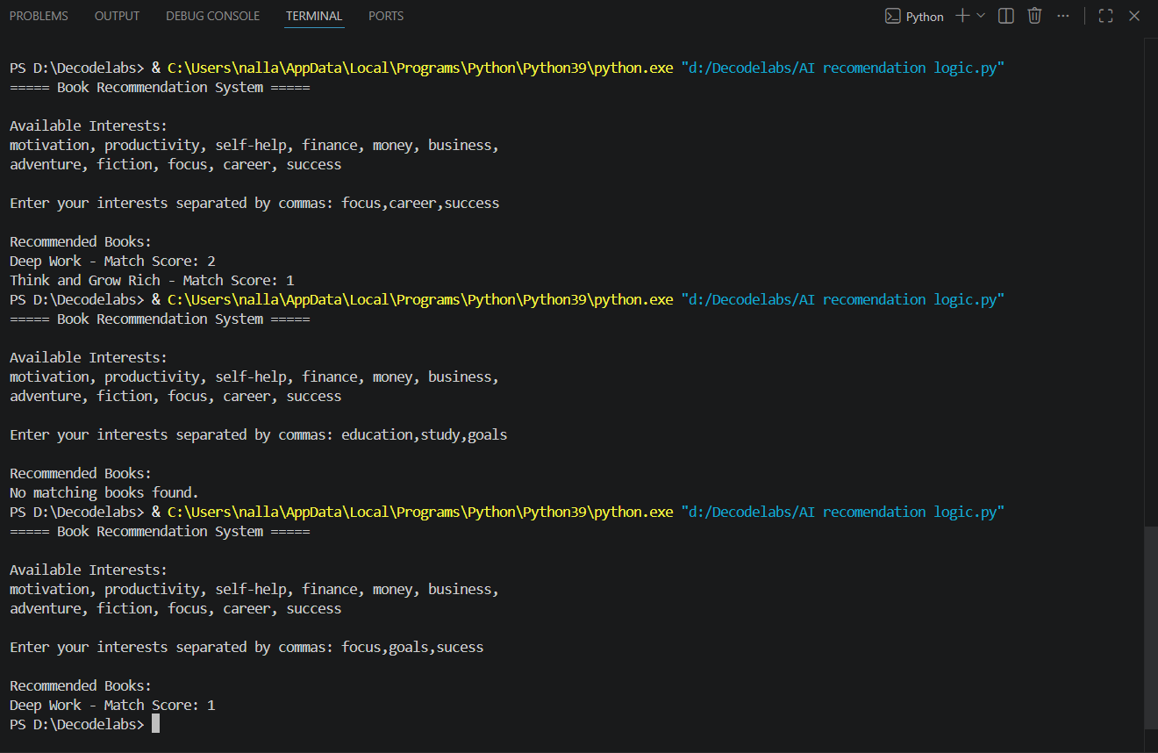

Recommendation Output 2



No Match Found Output



Learning Outcomes
Through this project, I learned:
- Recommendation system fundamentals
- Similarity-based recommendation logic
- Pattern matching concepts
- Python dictionaries and loops
- Data sorting and ranking
Conclusion
This project demonstrates how recommendation systems generate personalized suggestions by matching user interests with item attributes. It provides a foundation for understanding more advanced recommendation techniques used in modern AI applications.

